Ideation Phase

Brainstorm & Idea Prioritization Template

Date | 07 JULY 2026
Team ID | 23A51A1242
Project Name | Employee ID Card Request
Maximum Marks

Brainstorm & Idea Prioritization Template:

Brainstorming provides a free and open environment that encourages everyone within a team to participate in the creative thinking process that leads to problem solving. Prioritizing volume over value, out-of-the-box ideas are welcome and built upon, and all participants are encouraged to collaborate, helping each other develop a rich amount of creative solutions.

Use this template in your own brainstorming sessions so your team can unleash their imagination and start shaping concepts even if you're not sitting in the same room.

Step-1: Team Gathering, Collaboration and Select the Problem Statement

Problem Statement:

Many organizations still process employee ID card requests manually through emails or paper forms. This process can lead to delays, difficulty in tracking requests, and increased administrative effort. An automated ServiceNow-based solution is needed to streamline the request process, obtain manager approval, notify employees, and create tasks for the admin team.

Objective:

To automate the employee ID card request process using ServiceNow Service Catalog and Flow Designer. The system will allow employees to submit requests, route them for manager approval, send notifications after approval, and create tasks for the admin team.

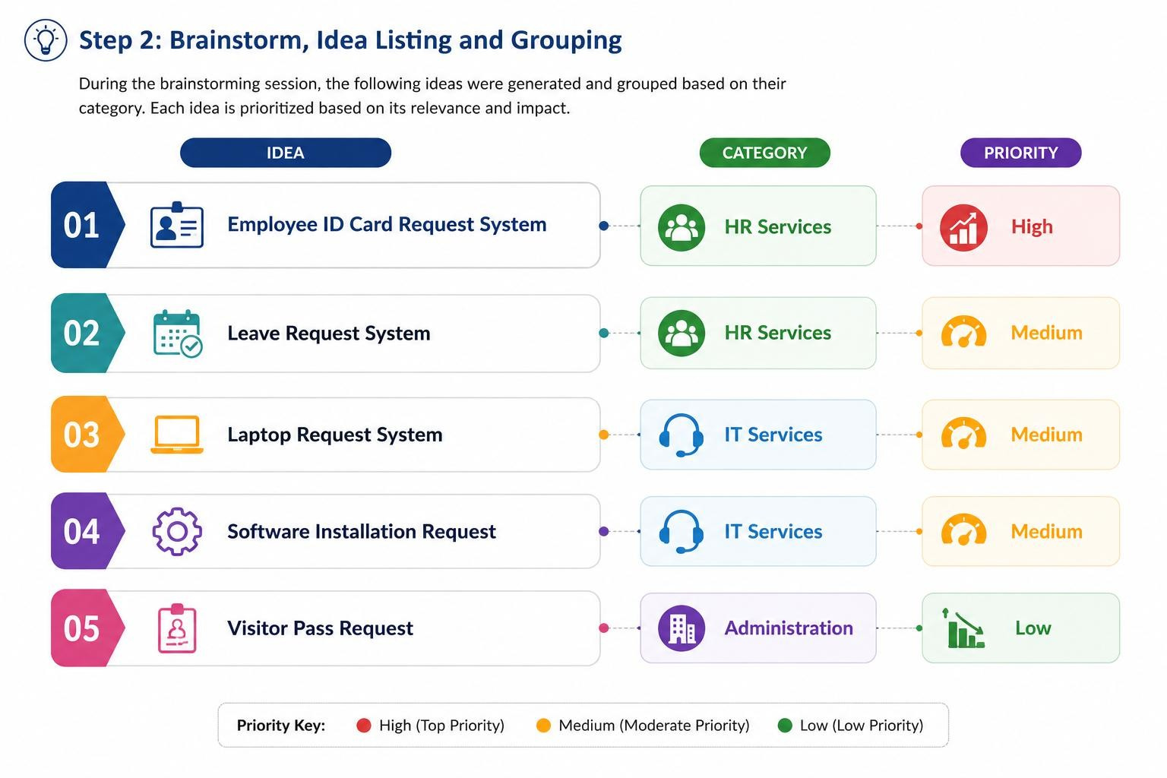

Selected Idea
Employee ID Card Request System using ServiceNow

Reason for Selection
- Solves a real business problem.
- Easy to develop using ServiceNow.
- Uses Service Catalog and Flow Designer.
- Demonstrates approval workflow and automation.
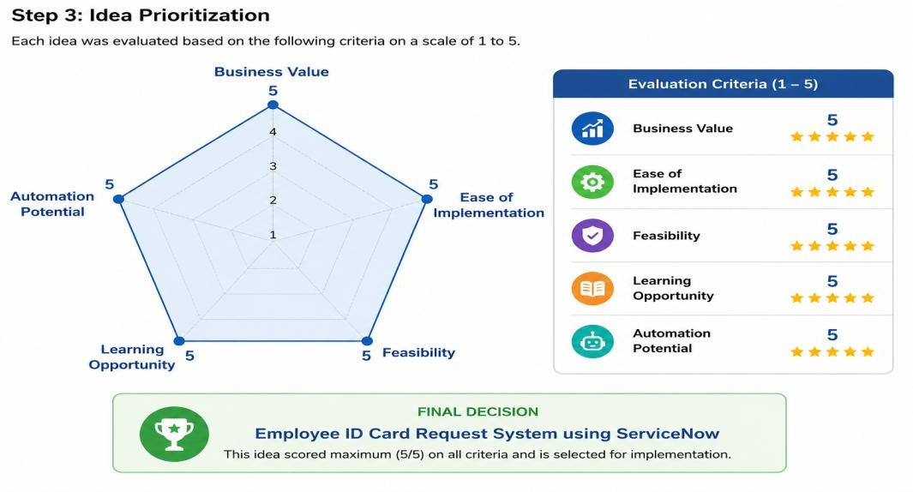
- Suitable for an internship project.

